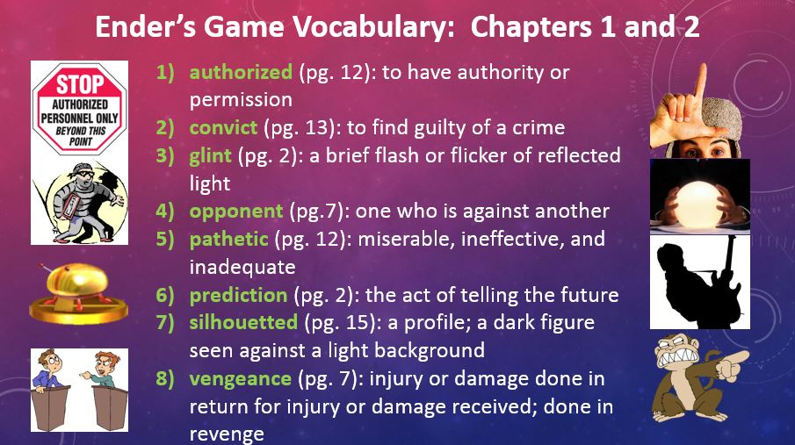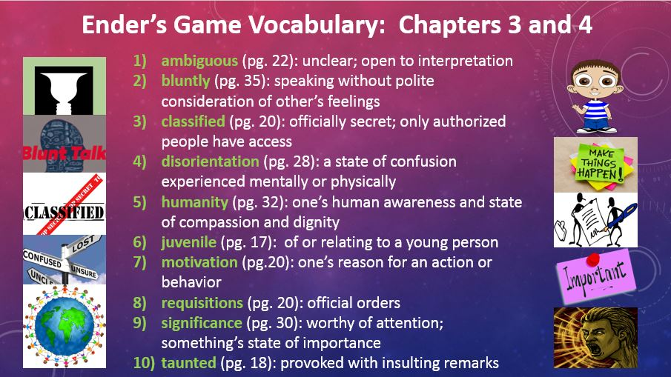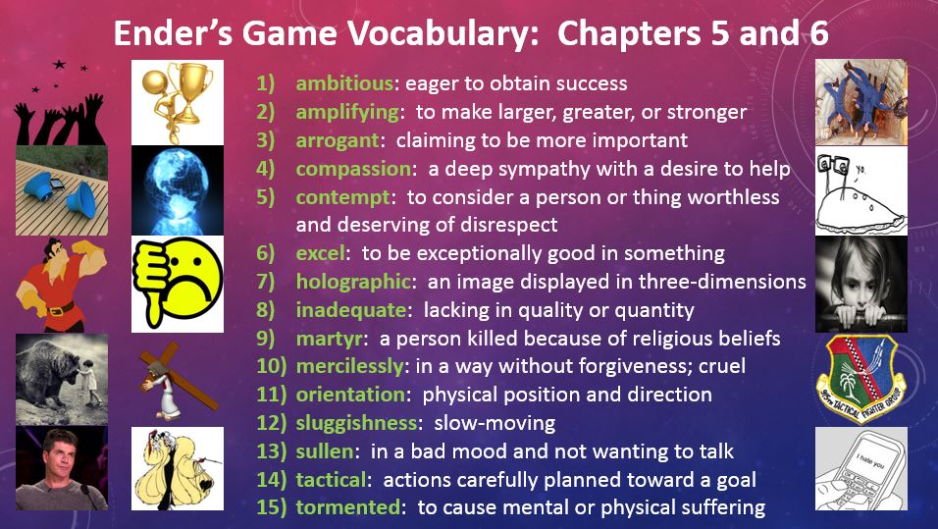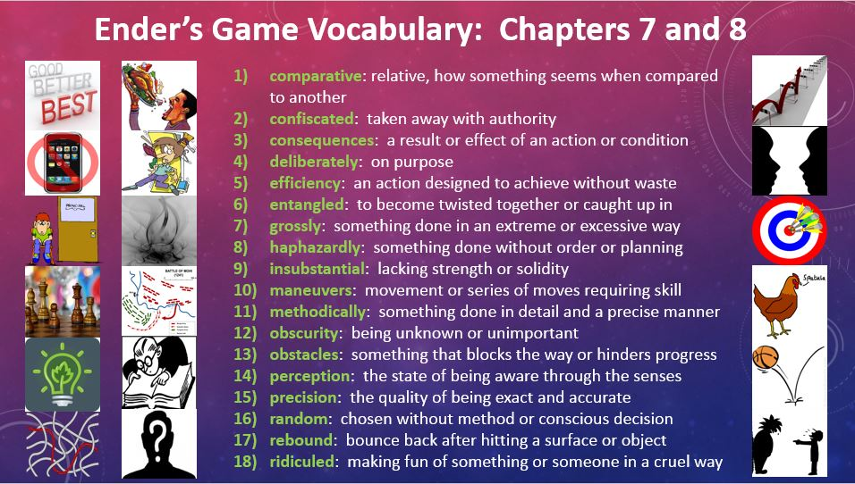

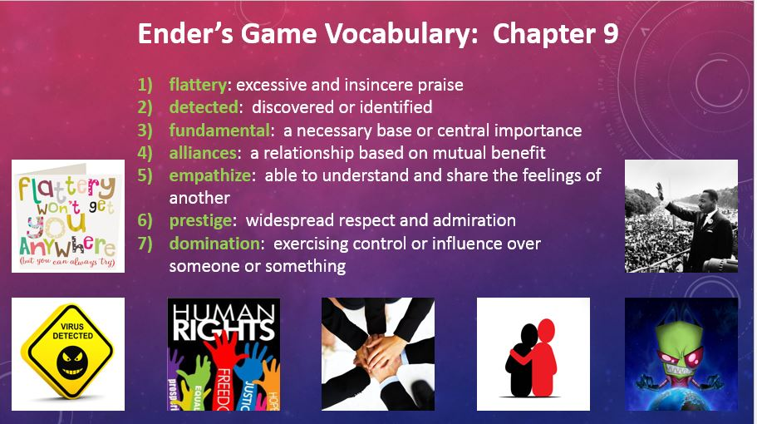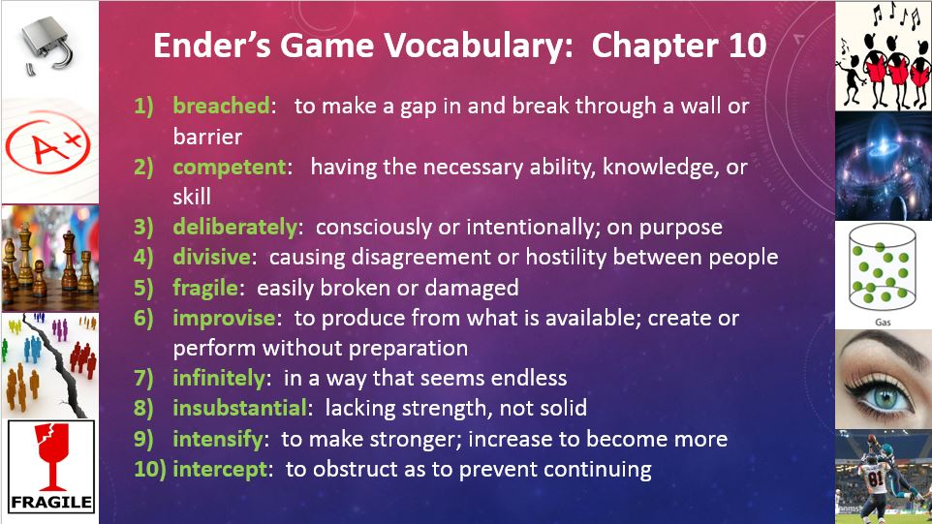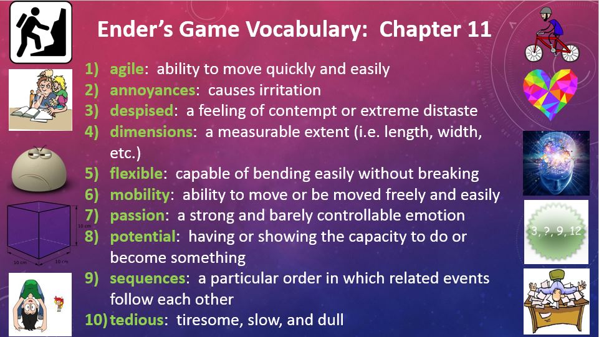

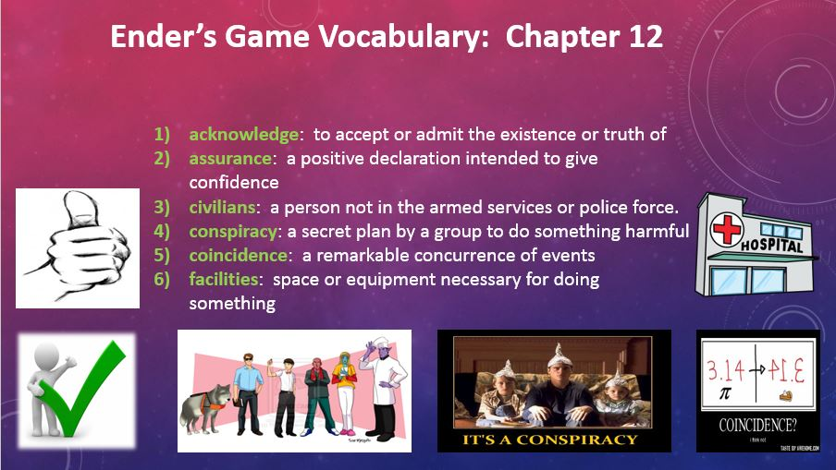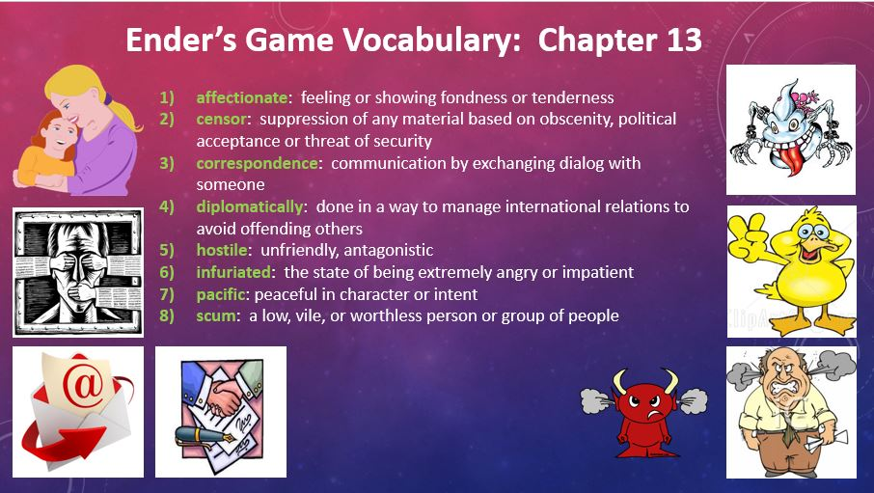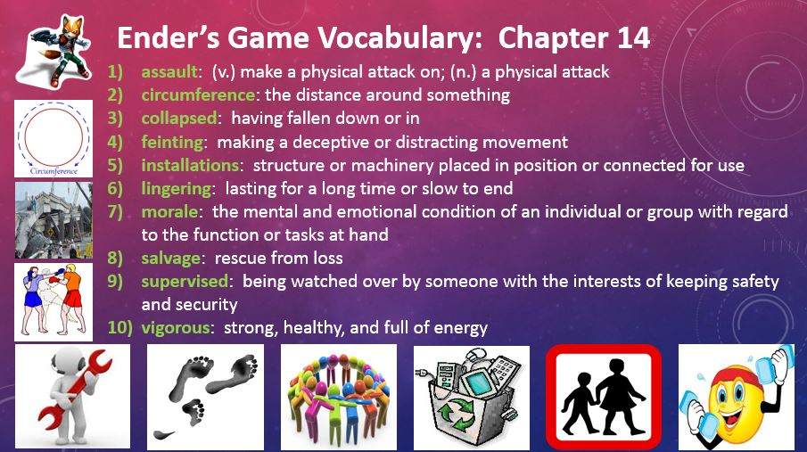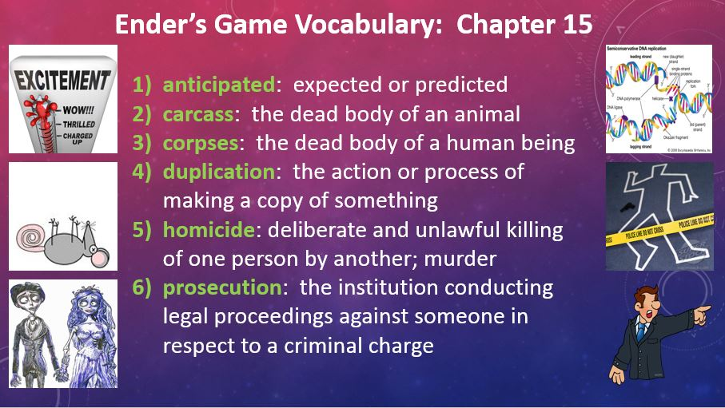

ENDER’S GAME VOCABULARY – PERSONAL DICTIONARY ENTRY

- acknowledge: to accept or admit the existence or truth of
- affectionate: feeling or showing fondness or tenderness
- agile: ability to move quickly and easily
- alliances: a relationship based on mutual benefit
- ambiguous (pg. 22): unclear; open to interpretation
- ambitious: eager to obtain success
- amplifying: to make larger, greater, or stronger
- annoyances: causes irritation
- anticipated: expected or predicted
- arrogant: claiming to be more important
- assault: (v.) make a physical attack on; (n.) a physical attack
- assurance: a positive declaration intended to give confidence
- authorized (pg. 12): to have authority or permission
- bluntly (pg. 35): speaking without polite consideration of other’s feelings
- breached: to make a gap in and break through a wall or barrier
- carcass: the dead body of an animal
- censor: suppression of any material based on obscenity, political acceptance or threat of security
- circumference: the distance around something
- civilians: a person not in the armed services or police force.
- classified (pg. 20): officially secret; only authorized people have access
- coincidence: a remarkable concurrence of events
- collapsed: having fallen down or in
- comparative: relative, how something seems when compared to another
- compassion: a deep sympathy with a desire to help
- competent: having the necessary ability, knowledge, or skill
- confiscated: taken away with authority
- consequences: a result or effect of an action or condition
- conspiracy: a secret plan by a group to do something harmful
- contempt: to consider a person or thing worthless and deserving of disrespect
- convict (pg. 13): to find guilty of a crime
- corpses: the dead body of a human being
- correspondence: communication by exchanging dialog with someone
- deliberately: consciously or intentionally; on purpose
- deliberately: on purpose
- despised: a feeling of contempt or extreme distaste
- detected: discovered or identified
- dimensions: a measurable extent (i.e. length, width, etc.)
- diplomatically: done in a way to manage international relations to avoid offending others
- disorientation (pg. 28): a state of confusion experienced mentally or physically
- divisive: causing disagreement or hostility between people
- domination: exercising control or influence over someone or something
- duplication: the action or process of making a copy of something
- efficiency: an action designed to achieve without waste
- empathize: able to understand and share the feelings of another
- entangled: to become twisted together or caught up in
- excel: to be exceptionally good in something
- facilities: space or equipment necessary for doing something
- feinting: making a deceptive or distracting movement
- flattery: excessive and insincere praise
- flexible: capable of bending easily without breaking
- fragile: easily broken or damaged
- fundamental: a necessary base or central importance
- glint (pg. 2): a brief flash or flicker of reflected light
- grossly: something done in an extreme or excessive way
- haphazardly: something done without order or planning
- holographic: an image displayed in three-dimensions
- homicide: deliberate and unlawful killing of one person by another; murder
- hostile: unfriendly, antagonistic
- humanity (pg. 32): one’s human awareness and state of compassion and dignity
- improvise: to produce from what is available; create or perform without preparation
- inadequate: lacking in quality or quantity
- infinitely: in a way that seems endless
- infuriated: the state of being extremely angry or impatient
- installations: structure or machinery placed in position or connected for use
- insubstantial: lacking strength or solidity
- insubstantial: lacking strength, not solid
- intensify: to make stronger; increase to become more
- intercept: to obstruct as to prevent continuing
- juvenile (pg. 17): of or relating to a young person
- lingering: lasting for a long time or slow to end
- maneuvers: movement or series of moves requiring skill
- martyr: a person killed because of religious beliefs
- mercilessly: in a way without forgiveness; cruel
- methodically: something done in detail and a precise manner
- mobility: ability to move or be moved freely and easily
- morale: the mental and emotional condition of an individual or group with regard to the function or tasks at hand
- motivation (pg.20): one’s reason for an action or behavior
- obscurity: being unknown or unimportant
- obstacles: something that blocks the way or hinders progress
- opponent (pg.7): one who is against another
- orientation: physical position and direction
- pacific: peaceful in character or intent
- passion: a strong and barely controllable emotion
- pathetic (pg. 12): miserable, ineffective, and inadequate
- perception: the state of being aware through the senses
- potential: having or showing the capacity to do or become something
- precision: the quality of being exact and accurate
- prediction (pg. 2): the act of telling the future
- prestige: widespread respect and admiration
- prosecution: the institution conducting legal proceedings against someone in respect to a criminal charge
- random: chosen without method or conscious decision
- rebound: bounce back after hitting a surface or object
- requisitions (pg. 20): official orders
- ridiculed: making fun of something or someone in a cruel way
- salvage: rescue from loss
- scum: a low, vile, or worthless person or group of people
- sequences: a particular order in which related events follow each other
- significance (pg. 30): worthy of attention; something’s state of importance
- silhouetted (pg. 15): a profile; a dark figure seen against a light background
- sluggishness: slow-moving
- sullen: in a bad mood and not wanting to talk
- supervised: being watched over by someone with the interests of keeping safety and security
- tactical: actions carefully planned toward a goal
- taunted (pg. 18): provoked with insulting remarks
- tedious: tiresome, slow, and dull
- tormented: to cause mental or physical suffering
- vengeance (pg. 7): injury or damage done in return for injury or damage received; done in revenge
- vigorous: strong, healthy, and full of energy

